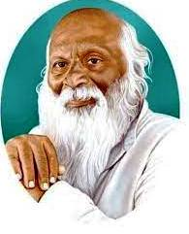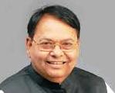Rayat Shikshan Sanstha’s

# Dr.Patangrao Kadam Mahavidyalaya Ramanandnagar (Burli)

# Cultural Committee and Department of Physics in collaboration with IQAC Organized Cooking Competition.

# Date27/09/2024

The cultural committee had organized a cooking competition for the students of B.Sc. I and B.Sc. II on 27th September, 2024. Cooking competition aimed to showcase culinary talents, encourage creativity in cooking and foster a competitive yet friendly environment for food enthusiastic.

This competition was successfully undertaken under the guidance of Hon. Principal Dr. Patil U.V., Dr.G.R.Patil and other faculty members. Students prepared various types of veg and non- veg recipes as per parameters set for cooking competition. Mrs. Borade and Mrs. Bhosale worked as jury for this competition.

**Outcomes:**

1. Foster originality and creativity in culinary arts.
2. Create a fun and engaging atmosphere for participants and spectators.

**Beneficiaries: - 24 Students**

**24**

|  |  |
| --- | --- |
| C:\Users\Dell\Downloads\WhatsApp Image 2025-01-18 at 11.54.49.jpeg | C:\Users\Dell\Downloads\WhatsApp Image 2025-01-18 at 11.54.50.jpeg |
| While inaugurating food competition | |
| C:\Users\Dell\Downloads\WhatsApp Image 2025-01-27 at 15.31.33.jpeg | C:\Users\Dell\Downloads\WhatsApp Image 2025-01-27 at 15.31.34.jpeg |
| While students enjoying competition | |

Head and Chairmen Principal

Dr. G. R. Patil 